KRUSKAL'S MINIMUM SPANNING TREE ALGORITHM
- Kruskal’s algorithm creates a minimum spanning tree from a weighted undirected graph by adding edges in increasing order of weights.
- Kruskal’s algorithm is greedy in nature as the edges are chosen in the increasing order of their weights.
- The algorithm makes sure that the addition of new edges to the spanning tree does not create a cycle within it.
- A union-by-rank & path compression technique used for merging two disjoint subsets could be used to efficiently add edges to the minimum spanning tree.

Algorithm : Kruskal’s minimum spanning tree ( Graph G )
0. Create an empty minimum spanning tree M i.e M = ∅ (zero edges)
1. Sort the edge-list of the graph G in ascending order of weights.
2. For each edge ( A, B ) in the sorted edge-list.
3. If Find_Set_Of_A != Find_Set_Of_B, then
4. Add edge A-B to the minimum spanning tree M i.e M = M + edge ( A - B )
5. Make a set / union of Find_Set_Of_A + Find_Set_Of_B.

Example of finding the minimum spanning tree using Kruskal’s algorithm
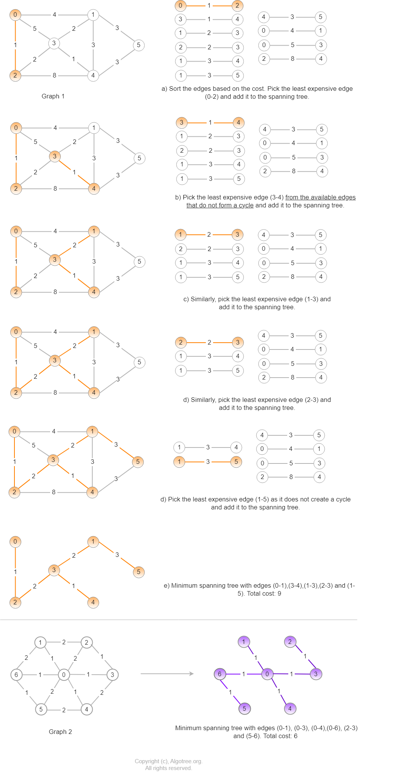
Time complexity of Kruskal’s algorithm : O ( E log ( E ) ) or O ( E log ( V )). Where E is the number of edges and V is the number of vertices.
Why is the time complexity of Kruskal's algorithm O ( E log ( E ) ) or O ( E log ( V ) ) ?

Kruskal’s minimum spanning tree implementation
PythonC++Java
import java.util.ArrayList;
import java.util.List;

class Edge {

int node_start;
int node_end;
int weight;
Edge (int node1, int node2, int wt) {
node_start = node1;
node_end = node2;
weight = wt;
}

public int GetWeight() {
return weight;
}
};

class Graph {

private int num_nodes;
private List<Edge> edgelist = new ArrayList<Edge>(); // Edgelist stores the edges of MST
private List<Integer> parent;
private List<Integer> rank;

Graph (int num_nodes) {
this.num_nodes = num_nodes;
parent = new ArrayList<Integer>(num_nodes);
rank = new ArrayList<Integer>(num_nodes);
}

public void AddEdge (Edge e) {
edgelist.add(e);
}

public int FindParent (int node) {

// With path compression
if ( node != parent.get(node) )
parent.set(node, FindParent(parent.get(node)));

return parent.get(node);

/* Without path compression
if ( node == parent.get(node) )
return node;

return FindParent(parent.get(node)); */
}

//Funtion implements Kruskal's algorithm and finds the minimum spanning tree.
public void KruskalMST (List<Edge> result) {

for (int i=0; i<num_nodes; i++) {
parent.add(i, i); // Initially set every node as the parent of itself.
rank.add(i, 0); // Initial rank of each node is 0.
}

// Lambda expression to sort the edges based on their weights
edgelist.sort((Edge e1, Edge e2)->e1.GetWeight()-e2.GetWeight());

for (Edge e : edgelist) {

int root1 = FindParent(e.node_start);
int root2 = FindParent(e.node_end);
// Union by rank technique to find minimum spanning tree.
if (root1 != root2) {
result.add(e);
if (rank.get(root1) < rank.get(root2)) {
parent.set(root1, root2);
rank.set(root2, rank.get(root2) + 1);
} else {
parent.set(root2, root1);
rank.set(root1, rank.get(root1) + 1);
}
}
}
}

public void DisplayEdges(List<Edge> result) {
int cost = 0;
System.out.print( "\nEdges of minimum spanning tree : ");

for (Edge edge : result) {
System.out.print( "[" + edge.node_start + "-" + edge.node_end + "]- (" + edge.weight + ") ");
cost += edge.weight;
}
System.out.println("\nCost of minimum spanning tree : " + cost);
}

public static void main (String args[]) {

int num_nodes = 6; // Nodes (0, 1, 2, 3, 4, 5)

// Edge (source, dest, weight);
Edge e1 = new Edge(0, 1, 4);
Edge e2 = new Edge(0, 2, 1);
Edge e3 = new Edge(0, 3, 5);
Edge e4 = new Edge(1, 3, 2);
Edge e5 = new Edge(1, 4, 3);
Edge e6 = new Edge(1, 5, 3);
Edge e7 = new Edge(2, 3, 2);
Edge e8 = new Edge(2, 4, 8);
Edge e9 = new Edge(3, 4, 1);
Edge e10 = new Edge(4, 5, 3);

Graph g1 = new Graph(num_nodes);

g1.AddEdge(e1);
g1.AddEdge(e2);
g1.AddEdge(e3);
g1.AddEdge(e4);
g1.AddEdge(e5);
g1.AddEdge(e6);
g1.AddEdge(e7);
g1.AddEdge(e8);
g1.AddEdge(e9);
g1.AddEdge(e10);

List<Edge> mst = new ArrayList<Edge>();
g1.KruskalMST(mst);
g1.DisplayEdges(mst);

num_nodes = 7;

Edge a = new Edge(0, 1, 1);
Edge b = new Edge(0, 2, 2);
Edge c = new Edge(0, 3, 1);
Edge d = new Edge(0, 4, 1);
Edge e = new Edge(0, 5, 2);
Edge f = new Edge(0, 6, 1);
Edge g = new Edge(1, 2, 2);
Edge h = new Edge(1, 6, 2);
Edge i = new Edge(2, 3, 1);
Edge j = new Edge(3, 4, 2);
Edge k = new Edge(4, 5, 2);
Edge l = new Edge(5, 6, 1);

Graph g2 = new Graph(num_nodes);
g2.AddEdge(a);
g2.AddEdge(b);
g2.AddEdge(c);
g2.AddEdge(d);
g2.AddEdge(e);
g2.AddEdge(f);
g2.AddEdge(g);
g2.AddEdge(h);
g2.AddEdge(i);
g2.AddEdge(j);
g2.AddEdge(k);
g2.AddEdge(l);

mst.clear();
g2.KruskalMST(mst);
g2.DisplayEdges(mst);
}
}
Output
Edges of minimum spanning tree : [0-2]-(1) [3-4]-(1) [1-3]-(2) [2-3]-(2) [1-5]-(3)
Cost of minimum spanning tree : 9

Edges of minimum spanning tree : [0-1]-(1) [0-3]-(1) [0-4]-(1) [0-6]-(1) [2-3]-(1) [5-6]-(1)
Cost of minimum spanning tree : 6

